Assessment-5

**CRUD Operations in MongoDB**

**Group -2**

**NAME:** Devi Dasari **REGD.NO:**221FA04679**BRANCH:** CSE **SECTION:** 3C **SUBJECT:** MSD

# Objective:

To assess the understanding and implementation skills of CRUD (Create, Read, Update,Delete) operations using MongoDB in a practical scenario.

# Tasks:

1. **Create Operation (Insert Documents):**

* Create a new database named school.
* Insert 5 documents into a collection called students with fields: name, age, grade[from 5-10], subject, and attendance.

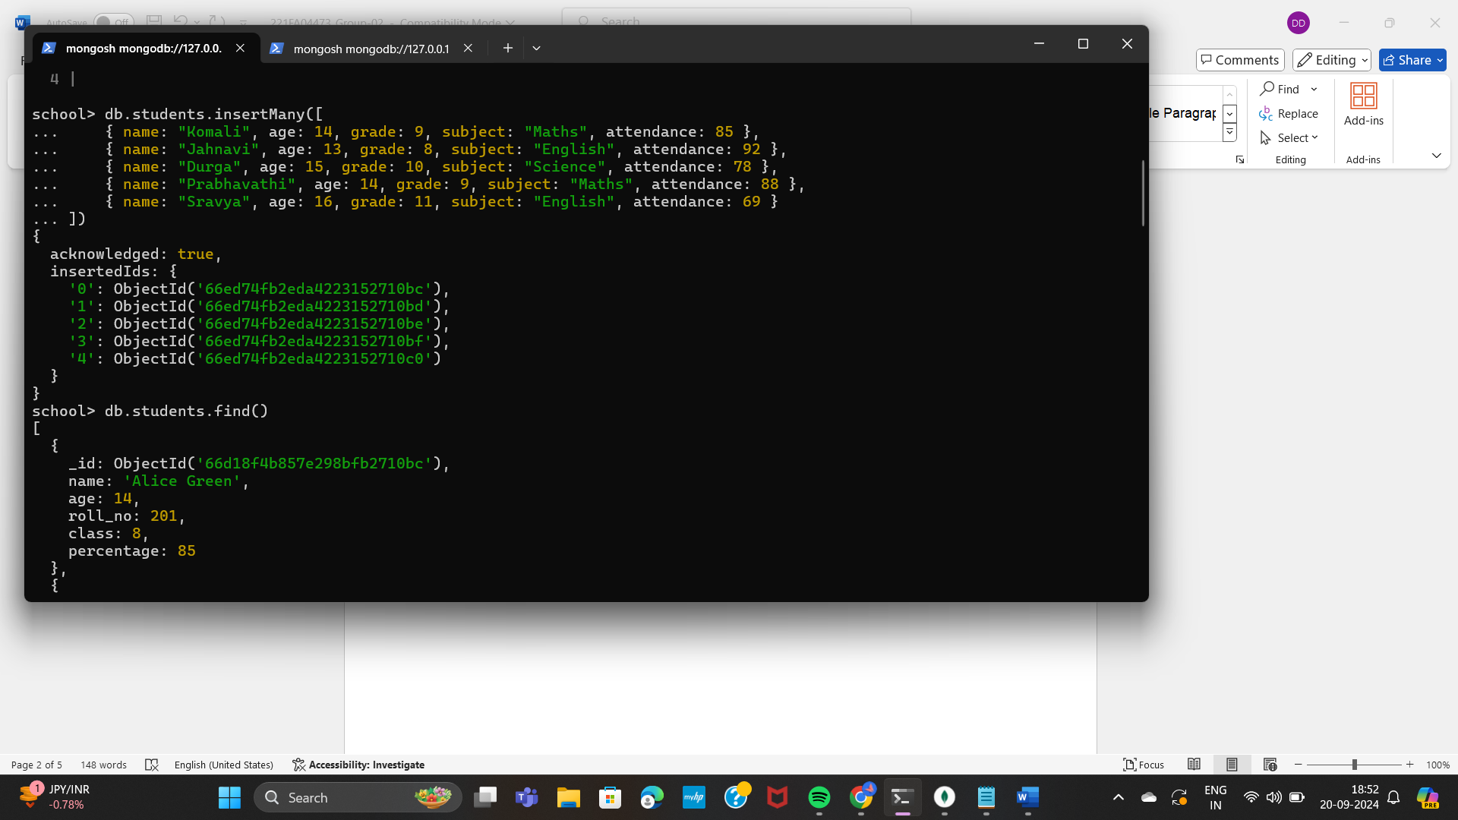

* .

# 2.Read Operation(Query Documents) :

Retrieve all documents from the students collection

Command**:** **school> db.students.find()**

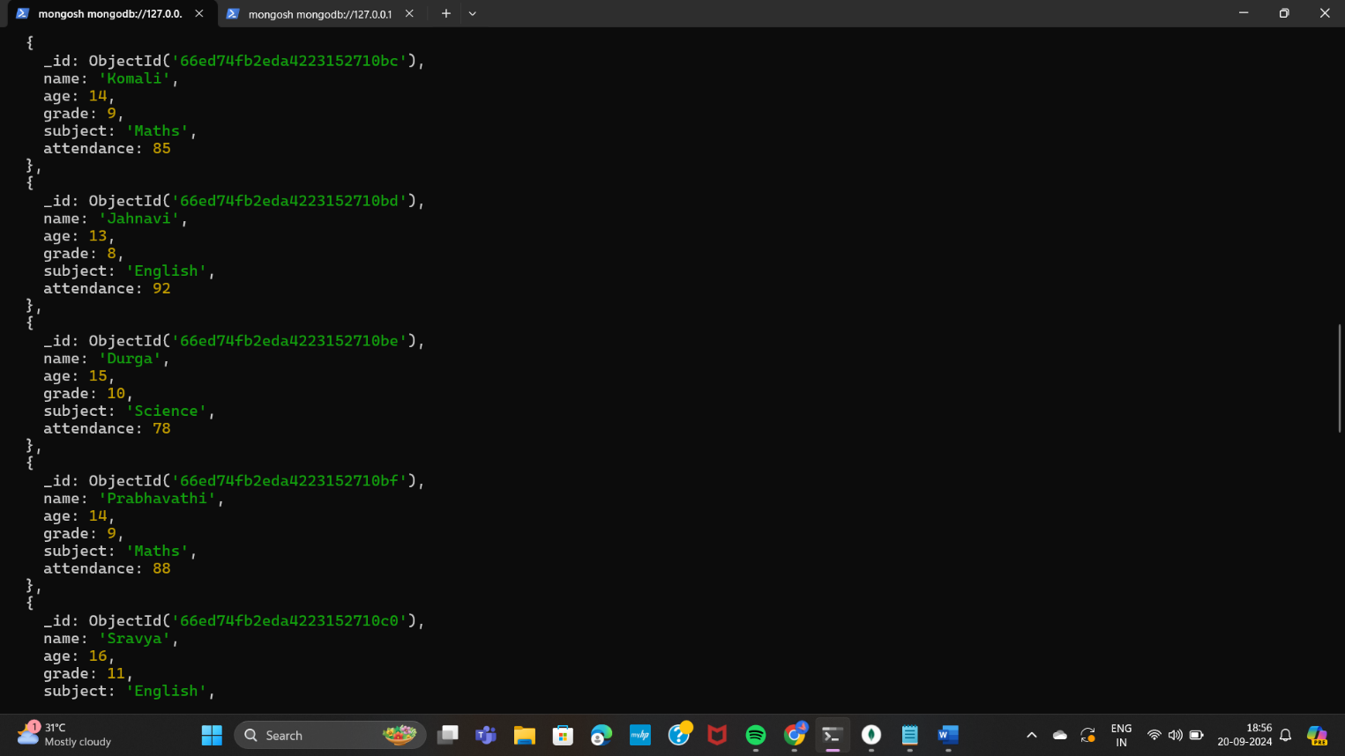

Write a query to find all students whose grade is greater than 8).

Command: **db.students.find({ grade: { $gt: 8 } })**

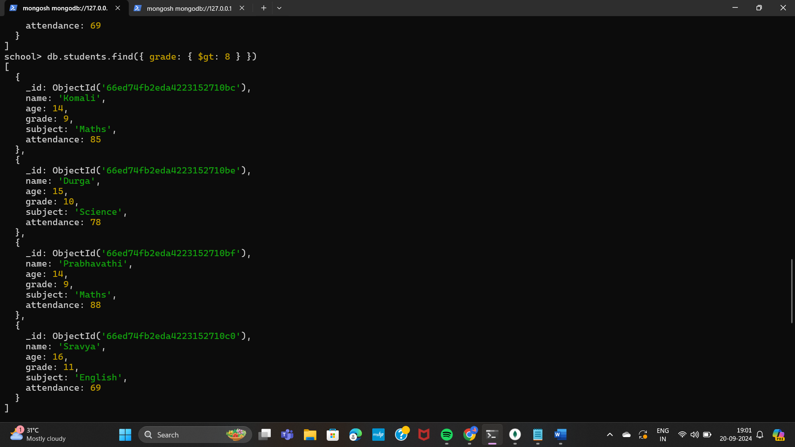

* Retrieve students who have Maths subject.
* Command: **db.students.find({ subject: "Maths" })**

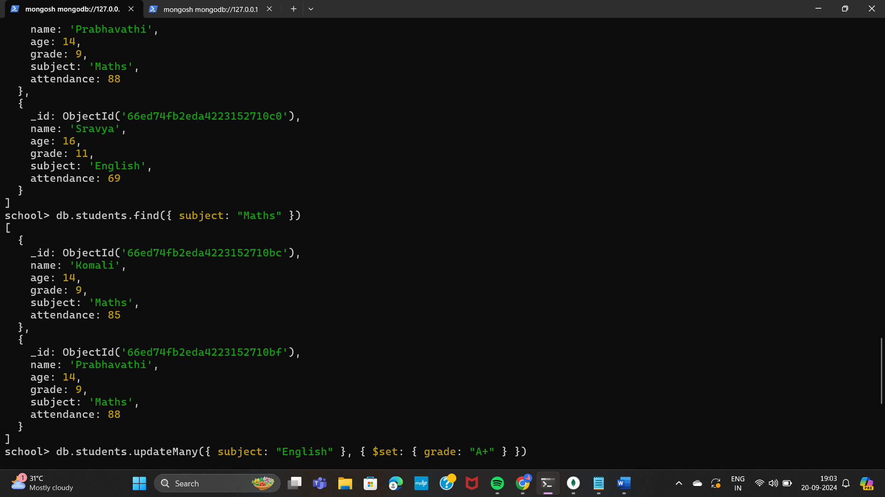

# 3.Update Operation (Modify Documents):

* Update the attendance of a student based on their name.
* Write a query to increase the grade of students to 9 who are studying English subject.

Command: **db.students.updateMany(**

**... {subject:"English"},**

**... {$set:{grade:9}}**

**... )**

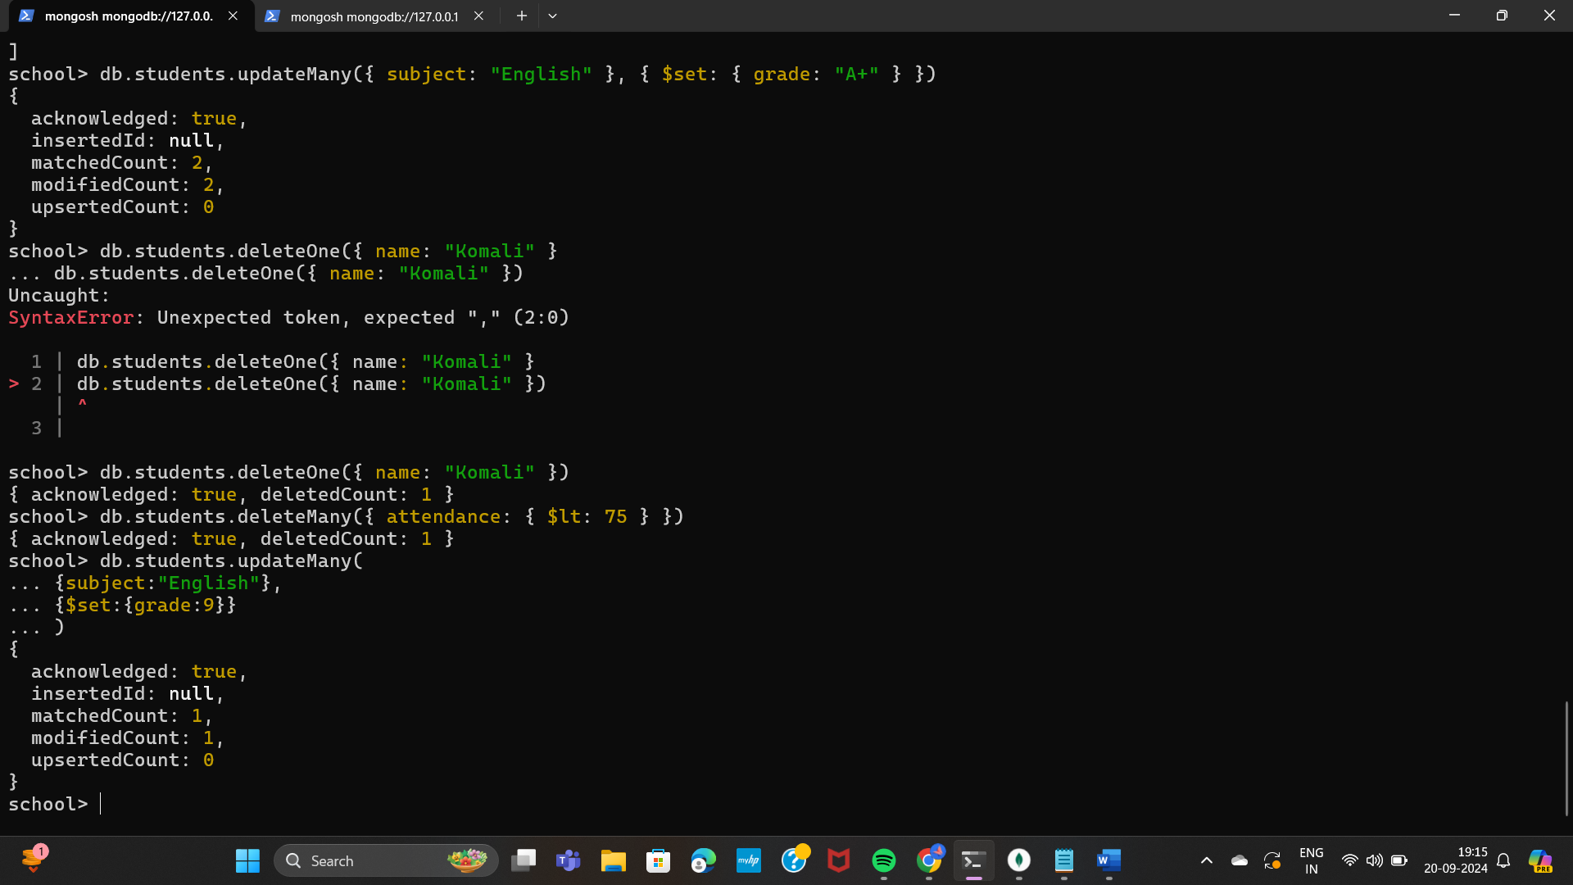

# 4.Delete Operation(Remove Documents):

* Write a query to delete a student by their name.
* Remove all students with attendance less than 75%.
* Command: **db.students.deleteOne({ name: "Komali" })**
* Command:**db.students.deleteMany({ attendance: { $lt: 75 } })**

